


Neuschwanstein Castle

The Most Distinguished Surname Zwanziger

Certificate No.306863201594
Copyright 1998-2015 Swyrich Corporation. All Rights Reserved www.houseofnames.com 888-468-7686

Table of Contents
Surname History
Origins 3
Ancient History 3
Spelling Variations 3
Early History 4
Early Notables 4
The Great Migration 5
Current Notables 5
Surname Symbolism
Introduction 8
Motto 8
Shield 9
Crest 11
Further Readings and Bibliography Appendix - Settler List 13
Bibliography 14

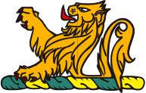

Certificate No.306863201594
Copyright 1998-2015 Swyrich Corporation. All Rights Reserved www.houseofnames.com 888-468-7686

Origins
The history of the Zwanziger family name begins in the German province of Bavaria. Zwanziger is a nickname surname, a class of German names derived from eke-names, or added names, that described people by a personal characteristic or other attribute. Zwanziger is a name for a graceful person. The name Zwanziger is derived from the German word "zwanen," which means "swan." There are also numerous places of this name in Germany because the swan symbolizes poetry, which was particularly popular during the Middle Ages.
Ancient History
Our research into the name Zwanziger brings us to Germany's largest state Bavaria, whose name stems from the ancient tribe of the "Bajuvaren." They settled here after coming from Bohemia, when the Romans ceased their occupation of the land south of the Danube in 500 A.D. Despite resistance from the Bavarian Duke Tassilo, the Holy Roman Emperor Charlemagne incorporated Bavaria into his empire in 788 A.D. The smaller part of Bavaria became part of the Empire in 976. Bavaria reverted to its former status of a dukedom, coming under the control of the houses of Saxony, then Franconia, and finally the Welfen family dynasty. Most of the German ducal houses held the imperial crown, such as the Wittelsbacher Ludwig the Bavarian, who was elected as Emperor by the Electors in 1314. The Welfen family enjoyed the peak of their power under Henry the Lion, Duke of Bavaria, from 1156 to 1180, until the Wittelsbach house, counts of the Palatinate, gained power.
After separating from the Ostmark, (now Austria) the duchy of Bavaria was ruled by the Wittelsbach dynasty from 1180 until 1918, when Germany became a republic. Interestingly, most Austrians are of Bavarian origin, and although Bavaria eventually lost its control over its southern neighbor, it gained through a pact with Napoleon the regions of Franconia, a section of Swabia, and a part of the Palatinate, and became a kingdom in its own right in 1806.
Bearers of Zwanziger were first found in this region during the Middle Ages in Bavaria, where the name Zwanziger was closely identified in early mediaeval times with the feudal society that would eventually shape the course of European history. The name would later emerge as a noble family with great influence, having many distinguished branches, and become noted for its involvement in social, economic and political affairs.

Certificate No.306863201594
Copyright 1998-2015 Swyrich Corporation. All Rights Reserved www.houseofnames.com 888-468-7686

Spelling Variations
Extensive research into the history and development of names has shown that the spelling of a surname varies greatly over time. The surname Zwanziger is no exception. In the mediaeval period, when very few people knew how to write, a name was often recorded in records or other official documents by scribes who wrote the name based on its sound. It was therefore possible that a name, depending on the local dialect, would even change between father and son. It was also common in Germany to add phrases to a name, in order to express something about a person's place of origin, religious background, or even character. Among the many variations of the name Zwanziger we find Zwanziger, Zwansiger, Zwanzger, Zwenziger, Zwenzger, Zwaenziger, Zwaenzger, Zwansigen, Zwanzigel, Zwanzigele, Zwenzigen, Zwenzigel, Zwenzigele, Zwaenzigen, Zwaenzigel and Zwaenzigele, to name a few examples.
Early History
From the 6th to the 12th century, the city of Regensburg was the residence of the Bavarian dukes. Another notable city is Augsburg, one of Germany's oldest cities founded by the Romans, as well as an important European trading center. Here two of the wealthiest families of the era had their seat: the Fuggers and the Welsers, who had tremendous power and influence as creditors to princes, nations, and even the Pope. Nuremberg was the cultural and economic center of the Empire; the famous painter Albrecht Duerer, as well as the poet Hans Sachs made this latter residence of the Emperor famous throughout the world.
Meanwhile bearers of the family name emerged in Bavaria, where they became more entrenched as one of the notable family names of the region. They established several branch houses of the name and some were not confined to the region. They moved within the great flux of migration in 16th and 17th century Europe. Many migrated to capitalize on their interests in religion, military and political service. Members of the Zwanziger family were rewarded for their loyalty and service when they were elevated to the Holy Roman Empire in 1784.

Certificate No.306863201594
Copyright 1998-2015 Swyrich Corporation. All Rights Reserved www.houseofnames.com 888-468-7686

Early Notables
The present capital of Bavaria is Munich, whose tremendous display of museums and galleries, not to mention the castle of Nymphenburg, is owed mostly to the generosity of Ludwig I, King of Bavaria and patron of the arts. The renowned tradition of German craftsmanship also has its place in Bavaria; in Augsburg the first mobile artillery was produced, as well as muskets in 1430. Augsburg weavers and textile manufacturers also became well known, while the city also became the site of many important treaties and parliaments. Nuremberg, where the pocket watch was invented, was the site of the first German railway in 1835. Wagner's opera, "Die Meistersinger," portrays the famous singing contests that took place in this historic city. Prominent bearers of the name Zwanziger in this period include the von Zwanziger family of Bavaria.
The Great Migration
Modern Bavaria is also known for its world-famous Oktoberfest, that celebrates in Munich the national pastime: the drinking of the local beer, an enjoyable tradition that is always popular with tourists from around the world. The Bavarian dialect, as with other southern German languages, has had the greatest influence in shaping our modern "Hochdeutsch" (standard German), and is seen as the source of the common German language. "Hochdeutsch" is used as a common tongue that all Germans, regardless of the tremendous variety of local dialects, can understand and use. Many inhabitants of this region sought their fortunes in the New World of North America, leaving the province of their birth to escape poverty or religious persecution, and for many Bavarian farmers the chance to own one's own land proved to be a major incentive. The process of the widespread colonization of North America began in 1650, where many immigrants from Germany settled in pockets based on a common religion or language. The vast majority of settlers found themselves in Pennsylvania, Texas, New York, Illinois, and California, while in Canada, German settlements centered around the province of Ontario and the Prairie regions. Among the settlers with the name Zwanziger we found Andreas Zwanzger, who arrived in Philadelphia in 1754; Georg Zwanziger came to America in 1783.; other settlers who established themselves along the eastern seaboard of the United States and in Canada during the 18th and 19th centuries.
Settlers
• Georg Zwanziger came to America in 1783
• Georg Zwanziger, who arrived in America in 1783
As well as 1 more in the Appendix.

Certificate No.306863201594
Copyright 1998-2015 Swyrich Corporation. All Rights Reserved www.houseofnames.com 888-468-7686

Current Notables
The greatest influx of immigrants to the United States occurred between the 1840s and the 1920s. Between these years, around 37 million immigrants arrived in the United States. Many of these later settlers followed opportunities westward.
There are 0 notables with similar origins in the Appendix.

Certificate No.306863201594
Copyright 1998-2015 Swyrich Corporation. All Rights Reserved www.houseofnames.com 888-468-7686

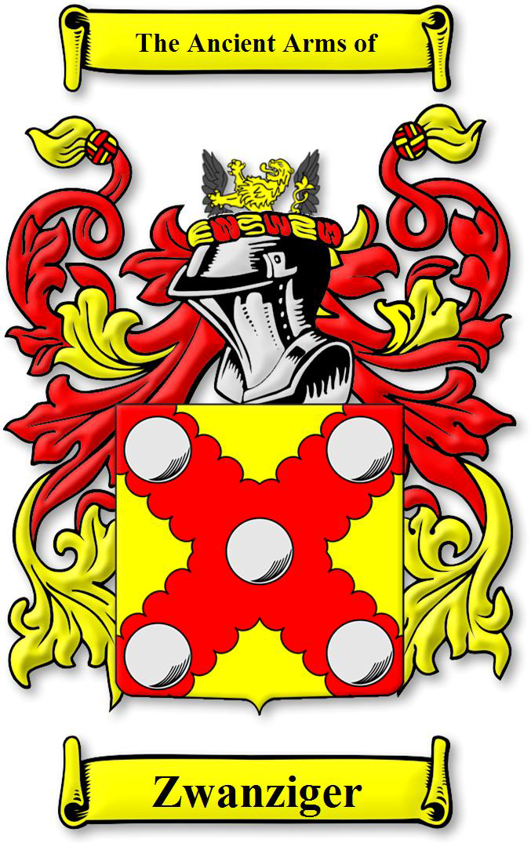

Certificate No.306863201594
Copyright 1998-2015 Swyrich Corporation. All Rights Reserved www.houseofnames.com 888-468-7686

Symbolism
In the feudal states of the Holy Roman Empire, that at one time encompassed most of eastern Europe, it was especially important to be able to identify enemies from allies because of the many conflicts that occurred there. A system of heraldry evolved that achieved this. It regulated what arms were borne, and allowed each of the German knights to be distinguishable from others.
Introduction
An Achievement of Arms such as the Zwanziger arms depicted on the left typically consists of these parts: the Escrolls, displaying the family motto and name, the family crest (if any) seen above the helmet, the actual Coat of arms (also known as 'arms,' or 'the shield'), the Helmet depicted below the crest, the Torse on top of the helmet, and the Mantle draped from the helmet. Each of these elements will be described below. Supporters were a
Achievement of Arms of Zwanziger

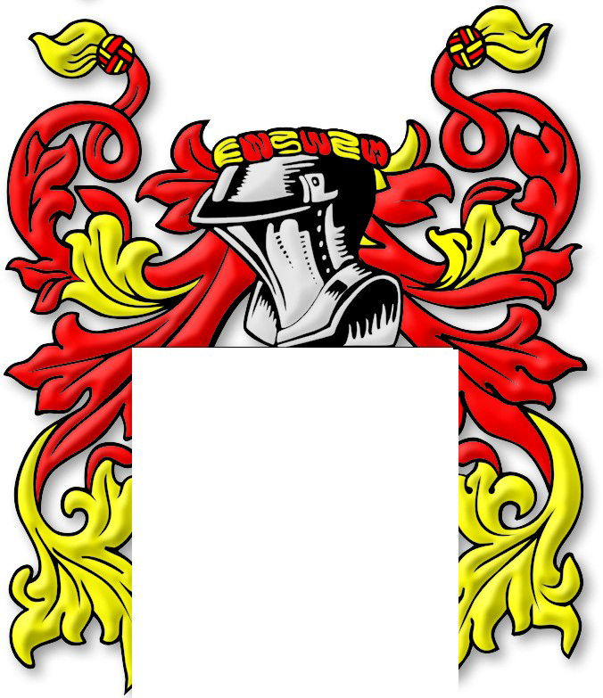

Mantle of Zwanziger

later addition to the Achievement; they are somewhat rare, and are usually personal to the grantee.

The mantle was spread over and draped from the helmet and served as a protection, 'to repel the extremities of wet, cold, and heat, and to preserve the armour from rust.' The numerous cuts and slits suggest that it had been torn and hacked on the field of battle. The style or design of the mantling is up to the individual heraldic artist, and it is usually depicted in the main color and metal from the shield. The helmet (or Helm) varied in shape in different ages and countries, often depicting rank. The Esquire's Helm, as depicted here, is generally shown silver, with a closed visor and facing to the dexter (its right). On top of the helmet is a Torse or wreath which was formed by two pieces of silk twisted together. Its purpose was to hold the crest and mantle on the Helm.

Certificate No.306863201594
Copyright 1998-2015 Swyrich Corporation. All Rights Reserved www.houseofnames.com 888-468-7686

Motto
The motto was originally a war cry or slogan. Mottoes first began to be shown with arms in the 14th and 15th centuries, but were not in general use until the 17th century. Thus the oldest coats of arms generally do not include a motto. Mottoes seldom form part of the grant of arms: Under most heraldic authorities, a motto is an optional component of the coat of arms, and can be added to or changed at will; many families have chosen not to display a motto.
The coat of arms displayed here for the surname Zwanziger did not include a motto.
Shield
Shields (or Escutcheons) at first were painted simply with one or more bands of color or 'ordinaries'. Later, the ordinaries were used in conjunction with other figures or symbols. The Coat of Arms for the surname Zwanziger can be described as follows:

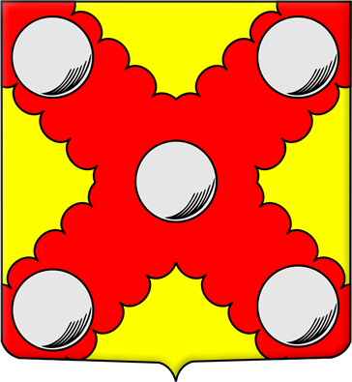
ZWANZIGER ARMS
A gold shield with five plates on a red saltire invected.

The Zwanziger Shield

Certificate No.306863201594
Copyright 1998-2015 Swyrich Corporation. All Rights Reserved www.houseofnames.com 888-468-7686



gold shield



plates

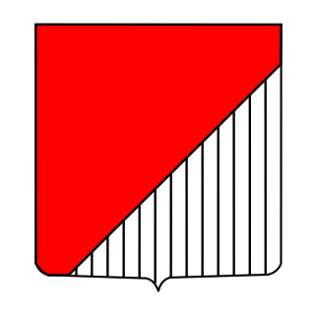

red

GOLD SHIELD
"Or" (from the French word for gold) is the tincture of gold and was considered the noblest color. One of only two metals used in heraldry, it exceeds all others in value, purity and finesse. It represents the light of the sun, and was once borne only by princes. Gold is said to gladden the heart and destroy all works of magic. It is also associated with excellence and achievement, and the bearer surpasses all others in valor. It is represented on coats of arms by the color yellow, and in engravings by an indefinite number of small points.
Symbolic Virtues: Or, the heraldic name for gold, symbolizes the virtues of faith, justice and mercy. Gold is the metal for excellence, as it is the purest and most unalloyed. It offers joy, success, prosperity and longevity.
Precious Stone: Carbuncle; Topaz
Planet: Sun
Obligations: To defend good and honor, and to fight to the death for one's country, surpasses all others in valor.

PLATES
The plate is a white or silver roundle, a roundle being any circular charge of color or metal. It represents a silver coin found in Spain during the Crusades. The name comes from the Spanish word "plata," meaning silver or silver coin. The plate signifies generosity.

RED
Gules, derived from an Old French word goules or gueules meaning "throats" translates into modern English as "red" and is the military color for excellence and fortitude. It is symbolic of nobility, boldness and ferocity, and can also represent fire and summer. Some ancient laws restricted its use to princes and their families. Red corresponds to the metal copper and is denoted in engravings by numerous perpendicular lines.

Certificate No.306863201594
Copyright 1998-2015 Swyrich Corporation. All Rights Reserved www.houseofnames.com 888-468-7686

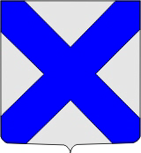

saltire

SALTIRE
The saltire is frequently found in Scottish arms because it is the well-known cross of St. Andrew, the patron saint of Scotland. In this case, it is most frequently found displayed under a chief.
Irish heraldry has occurrences to the saltire too. In this latter case, it usually shows the hereditary relationship to the Anglo-Norman "Fitz" surnames. This usage derives from the Norman (cognate with French fils - Latin filius), meaning "son of", which was coupled with the name of the father (e.g. Fitz Gilbert, meaning "son of Gilbert").
It is a cross running from corner to corner rather than vertically and horizontally like a crucifix. The saltire symbolizes suffering for faith and the endurance of hardships.
INVECTED
An invected line of partition is drawn like a the edge of a cloud, or a balloon with a knobbed outer; It is the reverse of engrailed.

The Crest
The Crest was worn on top of the helmet, and was usually made of wood, metal, or boiled leather. It provided the double advantage of easy identification and the addition of height to the wearer. The Crest for the surname Zwanziger is described as follows:


The top half of a gold lion between a pair of wings.
The Zwanziger crest

Certificate No.306863201594
Copyright 1998-2015 Swyrich Corporation. All Rights Reserved www.houseofnames.com 888-468-7686

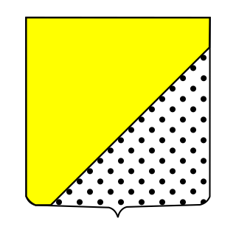

gold

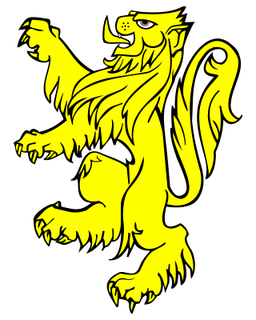

lion



wings

GOLD
"Or" (from the French word for gold) is the tincture of gold, or in heraldic terms "or," was considered the noblest color. One of only two metals used in heraldry, it exceeds all others in value, purity and finesse. It represents the light of the sun, and was once borne only by princes. Gold is said to gladden the heart and destroy all works of magic. It is also associated with excellence and achievement, and the bearer surpasses all others in valor. It is represented on coats of arms by the color yellow, and in engravings by an indefinite number of small points.
LION
The lion has always held a high place in heraldry as the emblem of deathless courage, and, hence, that of a valiant warrior. It is said to be a lively image of a good soldier, who must be "valiant in courage, strong of body, politic in council and a foe to fear." Through the somewhat dubious legend of their compassion, lions also came to symbolize Christ. As one medieval author asserted, "they prey on men rather than women, and they do not kill children except when they are very hungry." The lion, with such repute of its noble nature and having the position and title of king of the beasts, is naturally one of the most common heraldic symbols on the continent of Europe. The winged lion is the emblem of St. Mark.

WINGS
Wings are symbols of speed and protection. They are also religious emblems of justice and spirituality. Many European crests are blazoned to appear between a pair of wings, also called a "vol."

Certificate No.306863201594
Copyright 1998-2015 Swyrich Corporation. All Rights Reserved www.houseofnames.com 888-468-7686

Conclusion
Appendix - Settler List
American Settlers
• Georg Zwanziger came to America in 1783
• Georg Zwanziger, who arrived in America in 1783 Surname Variants of Zwanziger
• Andreas Zwanzger, who arrived in Philadelphia in 1754

Certificate No.306863201594
Copyright 1998-2015 Swyrich Corporation. All Rights Reserved www.houseofnames.com 888-468-7686

Bibliography
Here is a listing of some of the sources consulted when researching German surnames. The resources below directly or indirectly influenced the authors of our surname histories. We have most of these titles in our library, others we have borrowed or had access to. Source materials have been chosen for their reliability and authenticity. Our research into surnames is ongoing, and we are continually adding to our source library. For each surname history, we seek and refer to sources specific to the surname; these are generally not included in the list below.
Germany (Holy Roman Empire) Bahlow, Hans. And Edda Gentry, Transl. Dictionary of German
Kapff, Rudolf. Schwäbische Geschlechtsnamen. Stuttgart:
Verlag Silberburg, 1927.
Names. 2nd Ed. Madison: University of Wisconsin, 2002.
Bahlow, Hans. Abhandlungen zur Namenforschung und Buchgeschichte. 1980. (ISBN 9-78-376869-0522 )

Bahlow, Hans. Deutschlands geographische Namenwelt: Etymologisches Lexikon der Fluss- und Ortsnamen alteuropaischer Herkunft. Frankfurt: Suhrkamp, 1985.
Bahlow, Hans. Mecklenburgisches Namenbuchlein. Ein Fuhrer durch Mecklenburgs Familiennamen. Rostock: Carl Hinstorffs Verlag, 1932.
Brechenmacher, Josef Karlmann. Deutches Namenbuch. Stuttgart: Verlag von Adolf Bonz & Comp., 1928.
Bahlow, Hans. Mecklenburgisches Namenbuchlein. Ein Fuhrer durch Mecklenburgs Familiennamen. Rostock: Carl Hinstorffs Verlag, 1932.
Garland, Mary and Henry Garland. Eds. Oxford Companion to German Literature. 3rd Ed., Oxford: Oxford University Press, 1997. (ISBN 0-19-815896-3)
Gobel, Otto. Niederdeutsche Familiennamen der Gegenwart. Wolfshagen-Schabentz. Franz Westphal, 1936.
Gottschald, Max. Deutsche Namenkunde; unsere Familiennamen nach ihrer Entstehung und Bedeutung. München: J. F. Lehmanns Verlag, 1932.
Gotze, Alfred. Familiennamen im badischen Oberland. Heidelberg: Winter, 1918.

Kneschke, Dr. Ernst Heinrich. Neues allgemeines Deutsches Adels-Lexicon. 9 Vols. (New General German Aristocracy Lexicon). Leipzig: Friedrich Voigt, 1859.
Nied, Edmund. Fraenkische Familiennamen urkundlich gesammelt und sprachlich gedeutet. Heidelberg: C. Winter, 1933.
Preuss, Otto. Die Lippischen Familiennamen mit Berücksichtigung der Ortsnamen. Detmold: Meyer’sche Hofbuchh, 1887.
Bayerisch Stammenbuch von den alten abgestorbenen Fuerten

Rietstap, Johannes Baptist: Armorial General. Baltimore; Genealogical Publishing Co, 1965 (1861)

Schenk, Trudy. Wuerttemberg Emigration Index. Vol. I-VIII. Salt Lake City, UT, USA: Ancestry, Inc., 1986.

Steed, Henry Wickham The Hapsburg Monarchy. London: Constable and Company, 1919.
Tobler-Meyer, Wilhelm.: Familiennamen der Ostschweiz, Zurich: 1894

Tarneller, Josef. Zur Namenkunde. Tirolen Familiennamen. Bozen: Buchhandlung, 1923.
Zoder, Rudolf, Familiennamen in Ostfalen. Hildesheim: Geog Olms Verlagsbuchhandlung, 1968.
Haverkamp, Alfred. Medieval Germany: 1056-1273. 2nd ed.
Oxford: Oxford University Press, 1988.
Trusted Web-Sites
German State Archives: http://www.bundesarchiv.de/ Bavaria State Archives: http://www.gda.bayern.de/enp1.htm
Surnames
Cottle, Basil. The Penguin Dictionary of Surnames, 2nd ed.
London: Penguin, 1978.
Lower, Mark. Dictionary of Surnames. Hertfordshire
:Wordsworth Editions, 1968 (ISBN 1-85-326916-6)
Dunkling Leslie. Dictionary of Surnames. Toronto: Collins, 1998. (ISBN 0-00-472059-8)
Hanks, Patricia. And Flavia Hodges. A Dictionary of Surnames. Oxford: Oxford University Press, 1988. (ISBN 0-19-211592-8)
Hanks, Hodges, Mills and Room. The Oxford Names Companion. Oxford: Oxford University Press, 2002. (ISBN 0- 19-860561-7)

Certificate No.306863201594
Copyright 1998-2015 Swyrich Corporation. All Rights Reserved www.houseofnames.com 888-468-7686

Reaney P.H. And R.M. Wilson. A Dictionary of Surnames. London: Routledge, 1991.
Magnusson, Magnus. Chambers Biographical Dictionary. 5th ed. Edinburgh: W & R Chambers, 1990
Robb H. Amanda and Andrew Chesler. Encyclopedia of American Family Names. New York: HaperCollins, 1995 (ISBN 0-06-270075-8)

Heraldry
Brooke-Little, J.P. An Heraldic Alphabet. London: Robson,
1985. (ISBN 0-86051-320-3 PB)
Parker, James. Glossary of Terms Used in Heraldry. Rutland,
Vt: Tuttle, 1970. (ISBN 0-8048-0715-9)
Elvin, C.N. Elvin’s Handbook of Mottoes: Revised With Supplement and Index by R. Pinches. London: Heraldry Today, 1971. (ISBN 0-900455-04-7)
Foster, Joseph. Dictionary of Heraldry: Feudal Coats of Arms
and Pedigrees. London: Bracken Books, 1989. (ISBN 1-85170-309-
8)
Fox-Davies, Arthur. A Complete Guide to Heraldry. New York: Bonanza, 1978. (ISBN 0-517-26643-1)

Fox-Davies, Arthur. Heraldry: A Pictorial Archive for Artists & Designers. New York: Dover, 1991. (ISBN 0-486-26906-X)
Gritzner, M. Handbuch der heraldischen Terminologie in zwölf Zungen. Nürnberg: 1890.
Hildenbrand, A.M. Wappenfibel. Handbuch der Heraldik. Neustadt an der Aisch: 1970.
Koller, K. and A. Schillings. Armorial Universal. Brussels: Libraire Encyclopedique, 1951.

Pine, L.G. Heraldry and Genealogy. London: Teach Yourself Books, 1970. (ISBN 0-340-05614-2)

Puttock, Colonel A.G. Dictionary of Heraldry and Related Subjects. London: John Gifford, 1970.

Rolland, V. & H. V. Rolland: Illustrations to the Armorial general by J. B. Rietstap. Baltimore: Heraldic Book Co., 1967 (6 volumes in 3).
Siebmacher, J. Johann Siebmachers Wappenbuch. Munchen: Battenberg, 1975
Siebmacher, J. J. Siebmacher’s Grosses Wappenbuch. 35 Vols. Germany: Bauer & Raspe, 1979 (Reprint)
Uden, Grant. A Dictionary of Heraldry. London: Longmans, 1968. (ISBN 582-15471-9)
Von Volbroth, Carl-Alexander. Heraldry: Customs, Rules and Styles. London: New Orchard, 1991. (ISBN 1-95079-037-X)
Williamson, David. Debrett’s Guide to Heraldry and Regalia. London: Headline Book Publishing, 1992.
Neubecker, Ottfried: Großes Wappen-Bilder-Lexikon der
burgerlichen Geschlechter Deutschlands, Oesterreichs und der
Schweiz. Battenberg, München, 1985
Oswald, G. Lexicon der Heraldik. Leipzig: 1984. Woodcock, Thomas and John Martin Robinson. The Oxford
Guide to Heraldry. Oxford: Oxford University Press, 1988. (ISBN 0-19-285224-8)
Emigration
Bentley , Elizabeth P. Passenger Arrivals at the Port of New
York, 1820-1829. Baltimore, Maryland: Genealogical Publishing
Co., 1999.
Karlsruhe: Auswanderer, Badisches Generallandesarchiv: (Baden
Emigration lists)1866-1911. Salt Lake City. Microfilm of card
index by the Genealogical Society of Utah, 1976-1978.
Colletta, John P. They Came In Ships. Salt Lake City: Ancestry, 1993.
Filby , P. William an d Mar K. Meyer. Passenger and Immigration Lists Index. In Four Volumes. Detroit: Gale Research, 1985. (ISBN 0-8103-1795-8)

Fogleman, Aaron Spencer. Hopeful Journeys: German Immigration, Settlement, and Political Culture in Colonial America, 1717-1775. Philadelphia: University of Pennsylvania Press, 1986 (ISBN 978-0812215489)
Jones, George F. The Germans of Colonial Georgia, 1733-1783. Rev. edition Baltimore: Genealogical Publishers, 1986 (ISBN 0- 80-631161-4 )

Passenger Lists of Vessels Arriving at Galveston, Texas 1896-1951. National Archives, Washington, D.C.
Rupp, Daniel L. A Collection of Upwards of Thirty Thousand Names of German, Swiss, Dutch, French and Other Immigrants to Pennsylvania from 1727 to 1776. Baltimore: Genealogical
Publishing, 2000 (978-0806303024)
Samuelsen, W. David. New York City Passenger List Manifests Index, 1820-1824. North Salt Lake, Utah: Accelerated Indexing Systems International, 1986

Strassburger, Ralph B. Pennsylvania German Pioneers: The Original Lists of Arrivals in the Port of Philadelphia. 3 Vols. Baltimore: Picton Press,1992 (ISBN 9-78-092953-9980)
Thomas, Wilson B. and Emily S. Wilson. Directory of the Province of Ontario. Lambertville, NJ: Hunterdon House, 1857.
Jones, Henry Z. Palatine Families of New York. 2 Vols.
Rockland, ME: Picton Press, 2001 (ISBN 978-0961388829)
Canada
Baxter, Angus. In Search of your Canadian Roots: Tracing your
Cook, Ramsay, Réal Bélanger and Jean Hamelin. Dictionary of
Canadian Biography: 1921 To 1930. Toronto: University of
Toronto Press, 2006 (ISBN 0-80-209087-7)
Family Tree in Canada. Toronto: MacMillan, 1989. (ISBN 0-
7715-9201-9)
Beddoe Alan. Canadian Heraldry. Ottawa: Royal Heraldry Society of Canada, 1981.

Bercuson, David J. and J.L. Granatstein. Collins Dictionary of Canadian History: 1867 to Present. Toronto: Collins, 1988. (ISBN 0-00-217758-7)

Certificate No.306863201594
Copyright 1998-2015 Swyrich Corporation. All Rights Reserved www.houseofnames.com 888-468-7686

Jackson, Ronald Vern, et al. Canada 1800-1842 Census - Miscellaneous. North Salt Lake, Utah: Accelerated Indexing Systems International, 1989.
Maclean . Rose, George. A Cyclopaedia of Canadian Biography Being Chiefly Men of the Time: a collection of persons distinguished in professional and political life : leaders in the commerce and industry of Canada, and successful pioneers. Toronto: Rose, 1886.

Canadian Almanac and Directory -Annual editions. Toronto: Grey House.
Canadian Who’s Who. Toronto: University of Toronto Press, Published annually

Myers, Jan. Canadian Facts and Dates. Richmond Hill: Fitzhenry & Whiteside, 1991. (ISBN 1-55041-073-3)
Old United Empire Loyalists Lists. Baltimore: Genealogical Publishing, 1976. (ISBN 0-8063-0331-X)
Olivier, Reginald L. Your Ancient Canadian Family Ties. Logan, Utah: Everton Publishers, 1972.
Colombo, John Robert. Colombo’s Canadian Quotations.
Toronto: Colombo and Company, 1974.
United States
Best, Hugh. Debretts Texas Peerage. New York: Coward-
McCann, 1983 (ISBN:0-69-811244-X)
Egle, William Henry. Pennsylvania Genealogies: Scotch-Irish
and German. Harrisburg: L. S. Hart, 1886.
Bolton, Charles Knowles. Bolton’s American Armory. Baltimore: Heraldic book company, 1964.
Bradford, William. History of Plymouth Plantation,
1620–1647. Edited by Samuel Eliot Morrison. 2 vols. New York: Russell and Russell, 1968.
Browning, Charles, H. Americans of Royal Descent. Baltimore: Genealogical publishing, 2004 (1911). (ISBN 9-78-080630-0542)

Library of Congress. American and English Genealogies in the Library of Congress. Baltimore: Genealogical publishing, 1967.
Matthews, John. Matthews’ American Armoury and Blue Book. London: John Matthews, 1911.

Vermont, E. de V. American Heraldica: A Compilation of Coats of Arms, Crests and Mottoes of Prominent American Families Settled in This Country Before 1800. New York: Heraldic Publishing Company, 1965.
Weis, Frederick Lewis, Walter Lee Sheppard, and David Faris. Ancestral Roots of Sixty Colonists Who Came to New England Between 1623 and 1650. 7th ed. Baltimore: Genealogical publishing,1992. (ISBN:0-80-631367-6)
Crozier, William Armstrong Ed. Crozier’s General Armory: A
Registry of American Families Entitled to Coat Armor. New
York: Fox, Duffield, 1904.
Australia
Davison, Graeme, John Hirst and Stuart McIntyre Eds. The Oxford Companion to Australian History. South Melbourne: Oxford U. Press, 2001.
Fraser, John Foster. Australia: The Making of a Nation. London: Cassell, 1911.

Gillen, Mollie. Yvonne Browning and Michael Flynn. The Founders of Australia: A Biographical Dictionary of the First Fleet. Sydney: Library of Australian History 1989.
King, Jonathan. The First Fleet: The Convict Voyage That Founded Australia 1787-88. London: Secker & Warburg 1982.
Flynn, Michael, The Second Fleet, Britain’s Grim Convict
Armada of 1790. Sydney: Library of Australian History, 1993.
(ISBN 0-908120-83-4)
New Zealand Dictionary of New Zealand Biography: Volume one: 1769-1869.
Dictionary of New Zealand Biography: Volume Two: 1870-
1900. Auckland: Auckland University Press, 1993.
Auckland: Auckland University Press, 1990.
Extra Credit goes to Jan Arkesteijn at http://en.wikipedia.org/wiki/File:Neuschwanstein_Castle_LOC_print.jpg for the picture on the cover.

Certificate No.306863201594
Copyright 1998-2015 Swyrich Corporation. All Rights Reserved www.houseofnames.com 888-468-7686

